WEEK 1
1# Discuss the process by which Python executes a program, focusing on the stages involved from source code to execution.
Python does not execute a program directly from the .py file.
Instead, it follows a multi-stage compilation and interpretation pipeline. The Python interpreter first analyses and compiles the source program into an intermediate form called bytecode, and then executes it using the Python Virtual Machine (PVM). Hence Python is both compiled and interpreted.
The execution of a Python program consists of the following stages:
1. Reading the Source Code
The programmer writes a program in a text file with extension program.py. This file is called the source code and is written in high-level human-readable language.
2. Lexical Analysis (Scanning)
The first internal phase of execution is lexical analysis, performed by a component called the lexer or scanner. This is done to convert the stream of characters into meaningful units called tokens. The interpreter reads the program character-by-character and groups them into valid words of the Python language.
3. Tokenization
During tokenization, the program is broken into tokens. If the lexer finds an invalid word a lexical error occurs.
Types of Tokens:
- Keywords (if, else, while, def)
- Identifiers (variable names)
- Operators (+, -, *, /, =)
- Literals (numbers, strings)
- Delimiters ((), :, ,)
4. Syntax Analysis (Parsing)
After tokenization, Python checks whether the tokens follow the grammar rules of Python.
This stage is called parsing and is done by the parser. The parser verifies the program structure.

5. Construction of Abstract Syntax Tree (AST)
If the syntax is correct, Python converts the program into an internal representation called an Abstract Syntax Tree (AST). The AST is used by Python to understand what operation must be performed.
6. Compilation (AST to Bytecode)
The AST is then passed to the Python compiler. The compiler converts the AST into bytecode, which is a low-level intermediate instruction set. This step is why Python is called a compiled language at an intermediate level.
Bytecode is:
- Not machine code
- Not human readable
- Platform independent
7. Creation of .pyc File (Bytecode Storage)
The generated bytecode is saved in a file with .pyc extension. This speeds up program execution and avoids recompilation every time the program is run. Python recompiles only if the .py file is modified.
8. Python Virtual Machine (PVM) – Interpretation
The bytecode is executed by the Python Virtual Machine (PVM). The PVM is a software-based virtual processor that reads bytecode instructions and executes them one by one. Because the PVM executes instructions at runtime, Python is called an interpreted language.
9. Runtime Environment (Memory Management & Execution)
While executing the program, Python also activates its runtime system:
a) Memory Manager which creates objects, assigns variable references and maintains namespaces.
b) Garbage Collection which Python uses to automatically free unused memory using reference counting and cyclic garbage collector.
10. Interaction with Operating System
When a statement is executed, PVM calls Python’s I/O functions, Python makes system calls to the operating system and OS displays output on the screen. Finally the result appears.

#2 Discuss the fundamental features of Python programming language that make it widely used for modern software development.
Python is widely used in modern software development due to the following fundamental features:
- Simple and Readable Syntax: Python uses a clear and readable syntax, which makes programs easy to write, understand, and maintain.
- Interpreted Language: Python program are executed line by line, which simplifies debugging and speeds up development.
- Dynamically Typed: Variables do not require explicit type declaration, allowing flexible and rapid coding.
- Object-Oriented and Multi-Paradigm: Python supports object-oriented, procedural, and functional programming paradigms.
- Extensive Standard Library: Python provides a rich set of built-in modules and libraries, reducing the need to write code from scratch.
- Platform Independent/ Portability: Python programs can run on different operating systems without modification.
- Large Community Support: Python has a strong developer community, extensive documentation, and a wide range of third-party libraries.

3# Install IDLE interpreter for Python programming by following the steps mentioned below.
STEP 1: DOWNLOAD PYTHON 3.14
To start, go to python.org/downloads Click on Downloads tab and click on the button to download the latest version of Python:
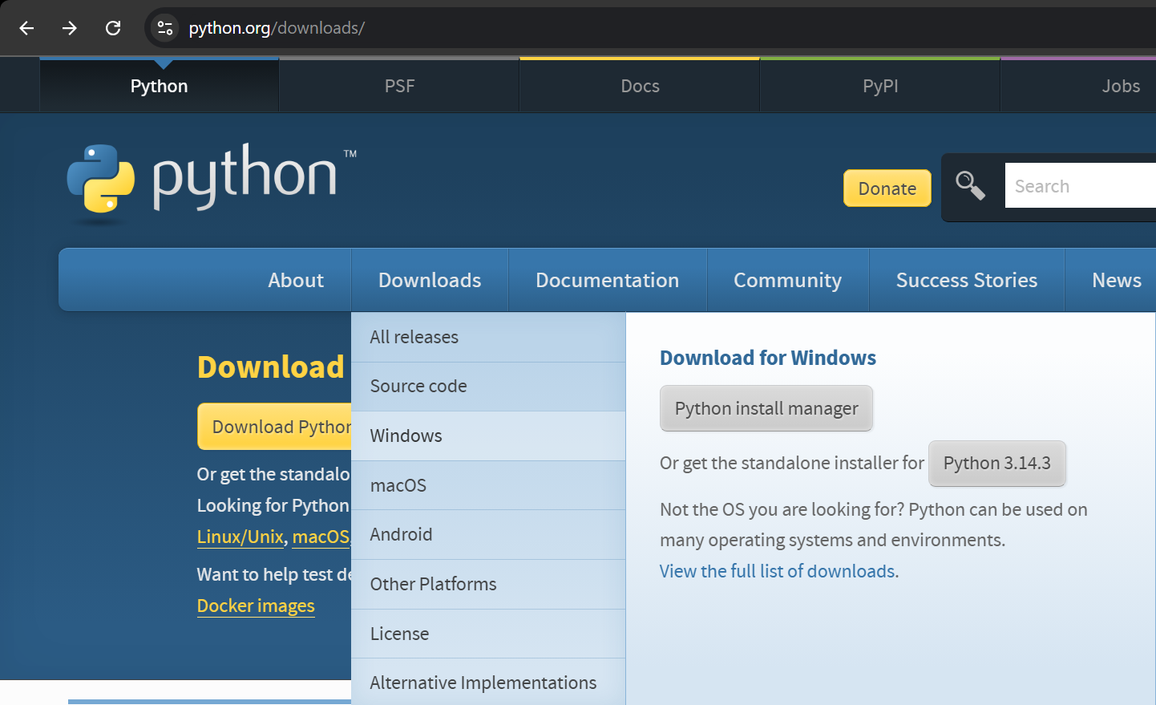
STEP 2: RUN THE .EXE FILE
Next, run the .exe file that you just downloaded.
STEP 3: INSTALL PYTHON 3.14
You can now start the installation of Python by clicking on Install Now. (Note that you can enable the Add Python to PATH option if required.)
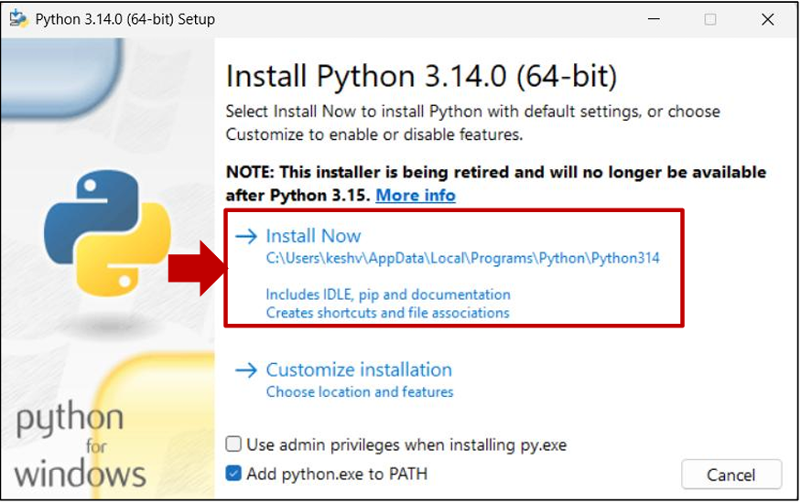

After a short period of time, your setup will be completed:
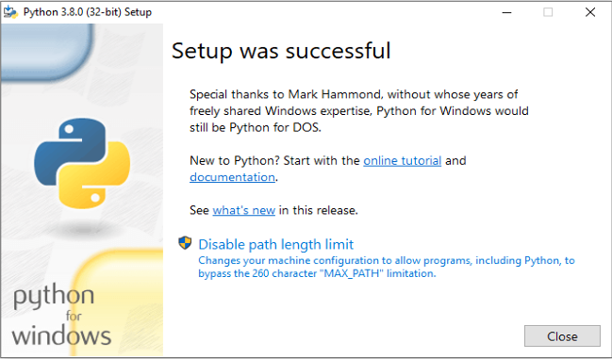

STEP 4: OPEN IDLE INTEGRATED DEVELOPMENT ENVIRONMENT FOR PYTHON
Once you click on the Python IDLE, you will then see the Shell screen:
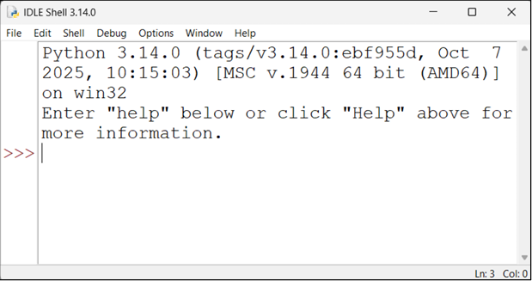

STEP-5: RUN FOLLOWING COMMAND IN IDLE INTERPRETER
print ('Hello, world')
print ('Python is object-oriented high-level programming language')
